LAB 8: DEMONSTRATE USAGE OF KEYWORD SUPER AND FINAL

Name: Shreyas Sawant Div: D7A Roll No.: 55

Q.1 Demonstrate any two uses of keyword super.

CODE:

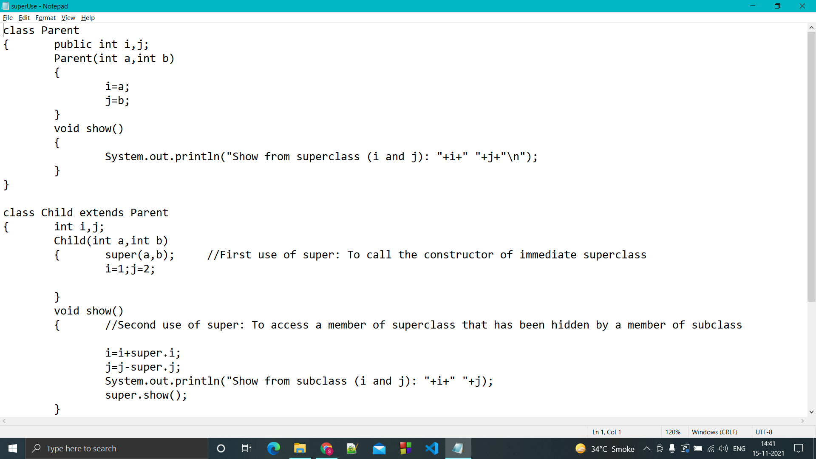

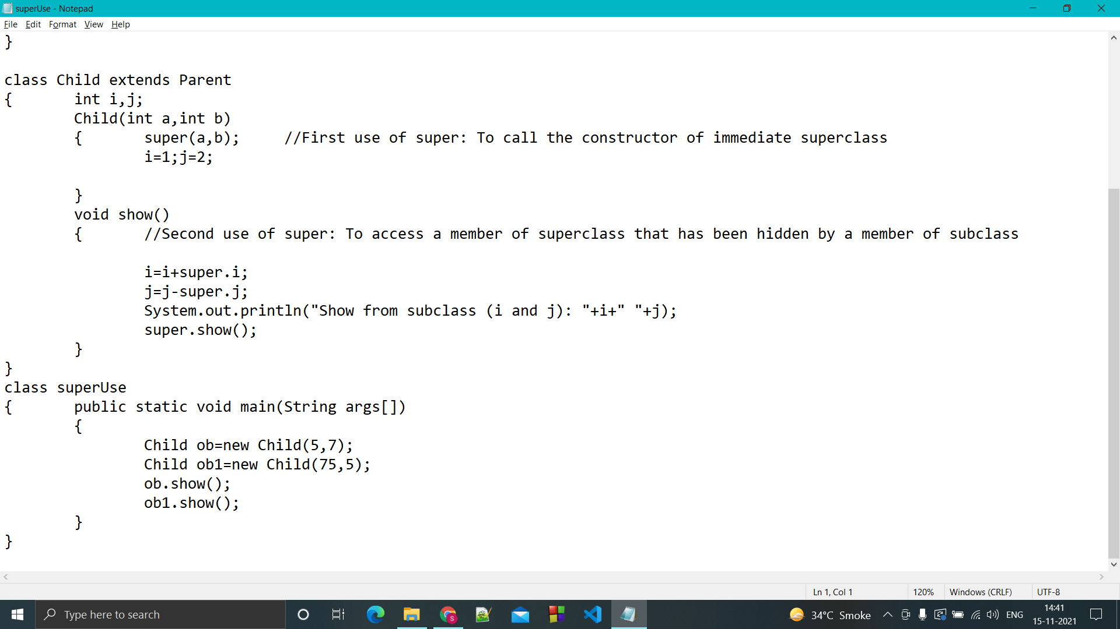

OUTPUT:

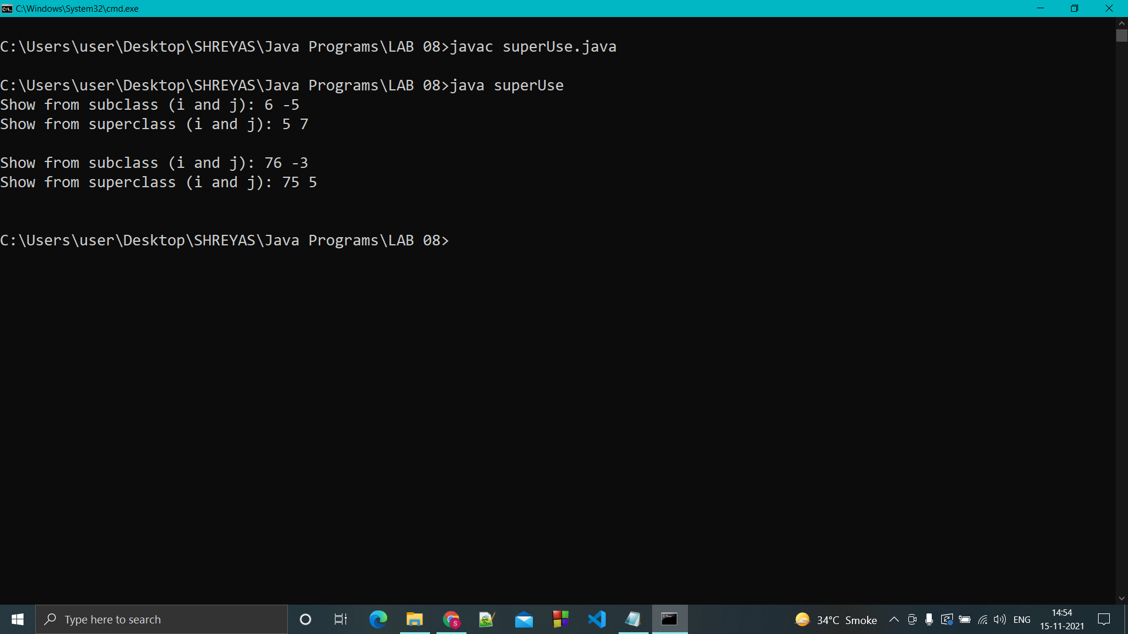

Q.2 Demonstrate the importance of keyword final in inheritance and method overriding.

CODE:

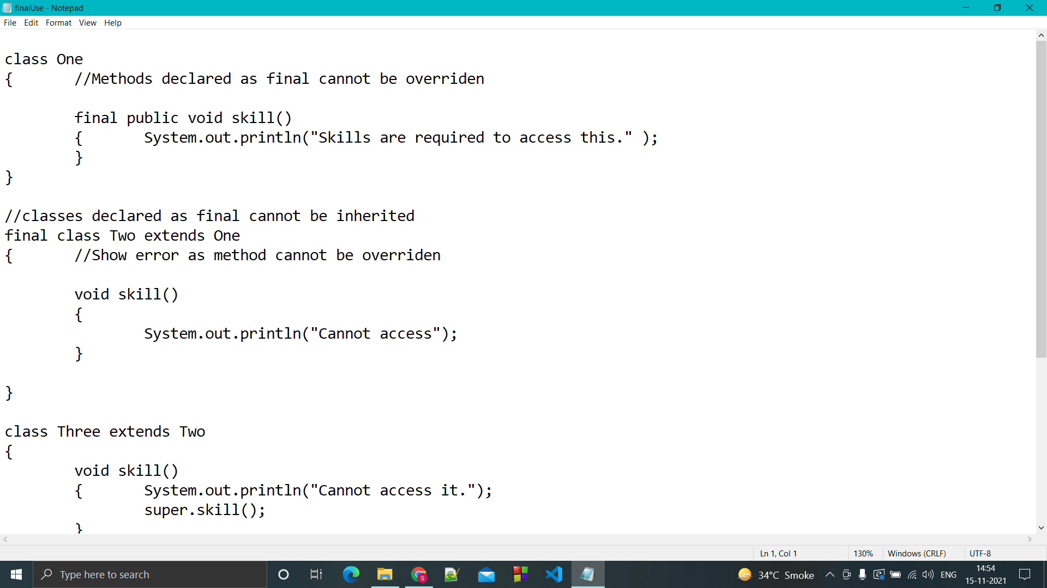

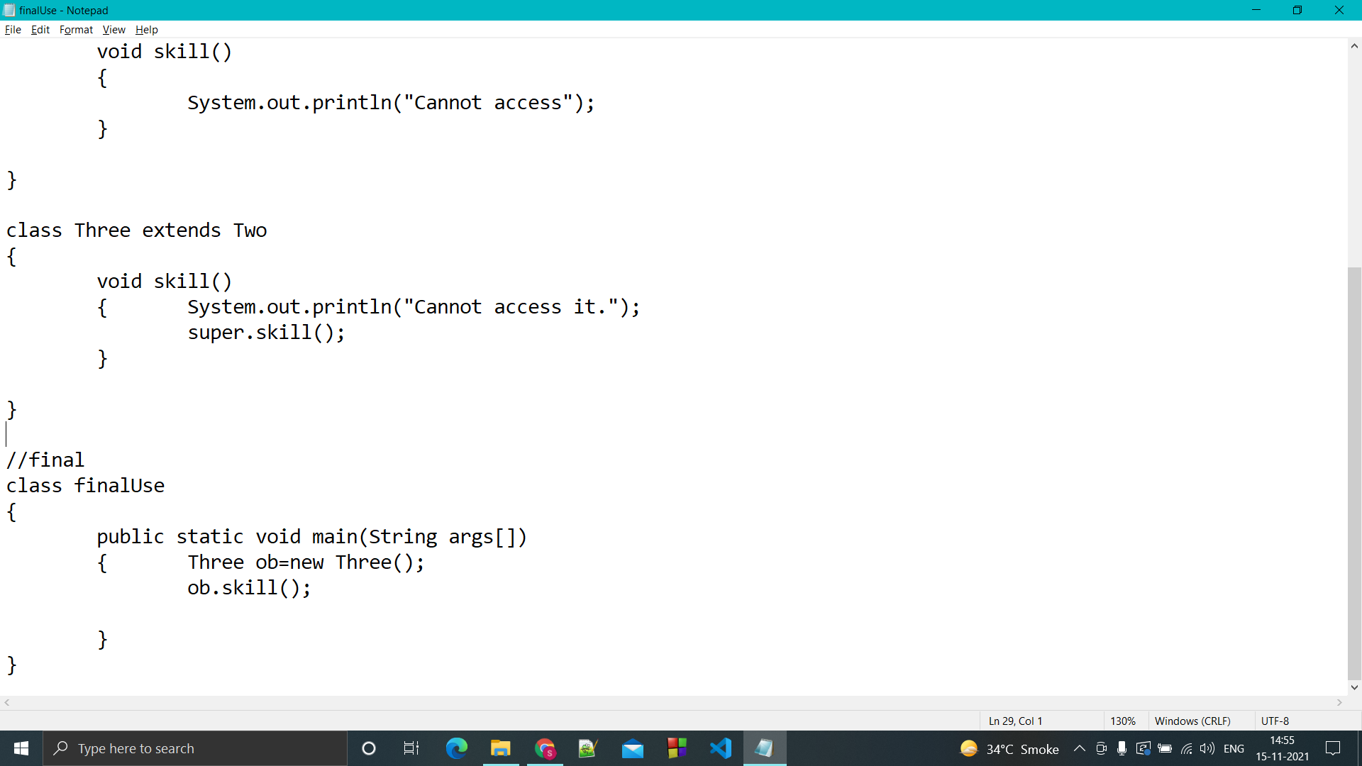

OUTPUT

